Functional Fresco MPX

Programmer's Guide

Members:
Luis Armendariz
Alex Hamilton
Sam Romano

10/8/2010
Table of Contents

Summary ........................….................................................................. 3
List of Commands ….............................................................................. 4
Commands
help ….......................................................................................... 5
help_ ….......................................................................................... 5
version ….............................................................................. 5
get_date ….............................................................................. 6
set_date ….............................................................................. 6
display_mpx ….............................................................................. 6
terminate_mpx ….................................................................. 7
change_prompt ….................................................................. 7
create_pcb...........................................................................................
delete_pcb...........................................................................................
block...................................................................................................
unblock................................................................................................
suspend................................................................................................
resume.................................................................................................
set_priority..........................................................................................
show_pcb............................................................................................
show_all..............................................................................................
show_ready.........................................................................................
show_blocked.....................................................................................
Index …...................................................................................................... 8

Summary

The Functional Fresco mpx OS was developed to test functional fresco's ability to develop an operating system. The second prototype of the mpx OS adds process management to the operating system. It does so by integrating a process control block (PCB) structure and queues that manage lists of processes. The second mpx OS prototype introduce a process management functions that will be utilized in all successive prototypes of the operating system. The following commands have been added in the second prototype: create_pcb, delete_pcb, block, unblock, suspend, resume, set_priority, show_pcb, show_all, show_ready, and show_blocked. The help command is very useful for identifying currently available commands and describing their purpose. We hope you enjoy our software and help us move towards greater tomorrows.
List of Commands

help: Displays help on the current acceptable commands.
help_: Displays information on a specified function.
version: Displays the current mpx OS Version Number.
get_date: Displays the current date(MM/DD/YYYY format).
set_date: Allows the user to set the current date.
display_mpx: Displays the available mpx Process Files.
terminate_mpx: Terminates the mpx OS.
change_prompt: Allows the user to change the prompt symbol.
create_pcb Sets up and allocates a new PCB.
delete_pcb Removes existing PCB and frees its memory.
block Places PCB in the blocked state.
unblock Places PCB in the ready state.
suspend Places PCB in the suspended state
resume Places PCB in the non suspended state.
set_priority Sets priority and adjusts position of PCB in ready queue.
show_pcb Shows information about selected PCB.
show_all Shows information about all PCBs.
show_ready Shows information about ready PCBs.
show_blocked Shows information about blocked PCBs.
Commands
help
The help command is a simple list of all commands in mpx os and a brief statement of their functionality. It can be called by typing "help" or "/?".
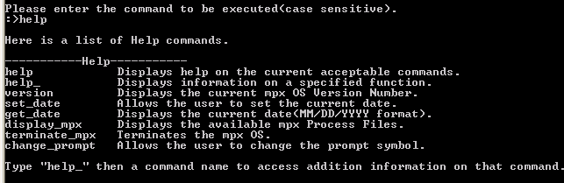
help_
The help_ command is called by typing "help_" and the command name. This command displays more detailed information about the command entered. Possible error:Invalid help_ command.
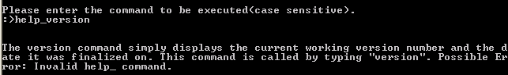
version
The version command simply displays the current working version number and the date it was finalized on. This command is called by typing "version". Possible Error: Invalid help_ command.
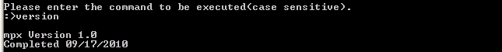

get_date
The get_date command grabs the set date and displays it. If there is no set date then the system date is acquired and displayed. This command can be accessed by typing "get_date" in the command prompt.
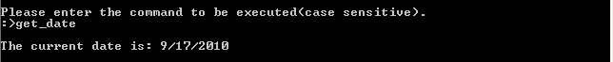
set_date
The set_date command takes in user input in the form of a string of numbers(MMDDYYYY) and sets that as the current date. The set_date command can be accessed by typing "set_date" in the command prompt. Possible Errors: Invalid Date, Date Not Changed.
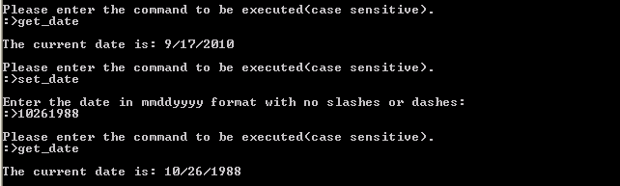
display_mpx
The display_mpx command is used to locate mpx files in a directory. The directory can be specified or the current directory can be selected by pressing enter once the prompt
for a directory has come up. Then all mpx files will be displayed with name, buffer size used, and file size. This command may be called by typing "display_mpx" in the command prompt. Possible Errors: Invalid Directory, Directory Not Open, No More Directory Entries, Read Failed, Name To Long For Buffer, No Directory Is Open.

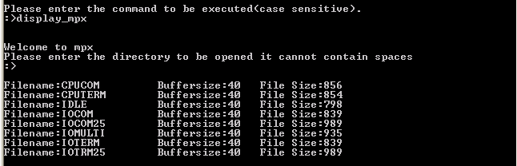
terminate_mpx
The terminate_mpx command exits the mpx os after it confirms with the user that the os is desired to exit. After confirmation allocated memory is cleared and the os terminates. This command may be called by typing either "quit","exit", or "terminate_mpx"in the command prompt.
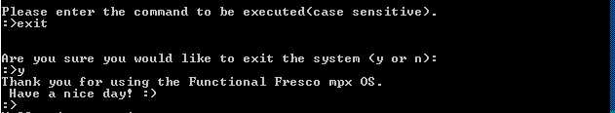
change_prompt
The change_prompt command replaces the standard :> prompt with any prompt that is desired and is 4 characters or less. This command is initiated by typing "change_prompt"in the command prompt.
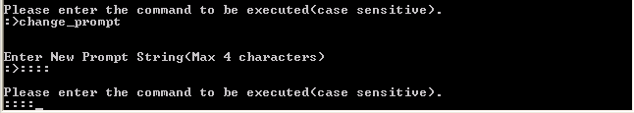

create_pcb

The create_pcb command allocates and sets up a new PCB and places it into the READY queue. The user must input the process name, class, and priority. This function throws an error if any of the following conditions are not met:
- process name not unique
- class must be valid(valid classes are 1 for SYSTEM and 2 for APP)
- priority must be between -128 and 127
(insert picture here)

delete_pcb
The delete_pcb command removes an existing PCB from its queue and frees its memory. The user must provide the process name in order to determine whether or not the PCB exists. The function throws an exception if the process name input by the user does not exist.

(insert picture here)
block
The block command places the PCB chosen by the user in the blocked state without changing its suspended status. The command accomplishes this by removing the PCB from the ready queue and placing it in the appropriate blocked queue. The user must input the name of the PCB. This function throws an error if the PCB name supplied by the user does not exist.
(insert picture here)

unblock
The unblock command places the PCB chosen by the user in the ready state without changing its suspended status. The user is required to input the name of the PCB to be unblocked. The command removes the PCB from the blocked queue and places it in the ready queue. This command throws an error if the PCB name does not exist or if the PCB is not properly removed from the blocked queue or inserted into the ready queue.

(insert picture here)

suspend
The suspend command receives the PCB name from the user and places the chosen PCB in the suspended state. This command accomplishes this by placing the chosen PCB into the appropriate suspended queue. The command throws an error if the removal or insertion of the PCB from or to a queue is unsuccessful.
(insert picture here)
resume
The resume command receives the PCB name from the user and places the chosen PCB in the not suspended state. This command accomplishes this by placing the chosen PCB into the ready or blocked queue. If the PCB is not correctly removed or inserted from or into the appropriate queue, the resume command will throw an error.
(insert picture here)

set_priority
The set_priority command allows the user to set the priority of a desired PCB. If the PCB is in the ready state, set_priority updates its position in the queue based on the new priority of the PCB. The command receives as input the name of the desired PCB and the new priority. set_priority throws an error if either the PCB name does not exist or the priority value is invalid(valid priorities = -128 – 127).
(insert picture here)

show_pcb
The show_pcb command requires the user to provide the name of a PCB and displays all of the information about the chosen PCB. The information shown includes the pcb name, class, state, priority, and memory size. If the PCB name does not exist, show_pcb throws an error.
(insert picture here)
show_all
The show_all command simply shows all information about every PCB currently in any of the queues. The information displayed for each PCB should fit on one line per PCB and should include name, priority, class, state, and memory size.
(insert picture here)

show_ready
The show_ready command displays all information about PCB in the ready queue. The information displayed, as well as the format, is the same as that of the show_all command. The command shows information of the processes in the order they exit the ready queue.
(insert picture here)

show_blocked
The show_blocked command is identical to the show_ready command except it performs the operation on all processes in the blocked queue.
(insert picture here)
Index
Commands
block..................................................................................................
change_prompt ….................................................................. 7
create_pcb...........................................................................................
delete_pcb...........................................................................................
display_mpx ….............................................................................. 6
get_date ….............................................................................. 6
help ….......................................................................................... 5
help_ ….......................................................................................... 5
resume.................................................................................................
set_date ….............................................................................. 6
set_priority..........................................................................................
show_all..............................................................................................
show_blocked.....................................................................................
show_pcb............................................................................................
show_ready..........................................................................................
suspend................................................................................................
terminate_mpx ….................................................................. 7
unblock................................................................................................
version ….............................................................................. 5

